Intelligent Educational System using Agentic

The rapid growth of Artificial Intelligence (AI) has transformed the education system by making learning more interactive, automated, and personalized. This project focuses on designing an AI-driven educational framework that integrates AIML, Prompt Engineering, Agent AI, and Agentic AI into a single automated system. All components work sequentially within a single chartboard or template, forming a unified intelligent learning environment.
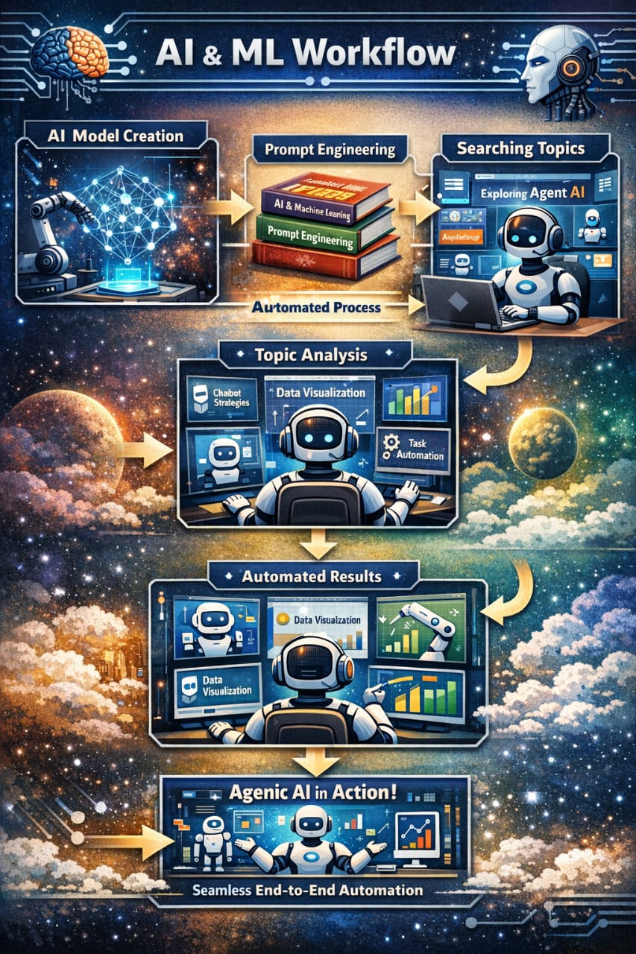
1. Creation of Universal Chartboard (AIML)
The universal chartboard acts as the core framework of the system.
It is developed using Artificial Intelligence and Machine Learning (AIML) concepts.
Serves as a centralized structure for all educational components
Integrates data processing, content organization, and learning workflows
Acts as the base layer that connects textbooks, topics, and AI agents
This chartboard visually represents the complete AI-powered educational process.
2. Educational Textbooks using Prompt Engineering
Inside the universal chartboard, a collection of educational textbooks is created using Prompt Engineering techniques.
Each textbook is generated and structured through optimized AI prompts
Subjects and concepts are organized systematically
Enables intelligent content generation, explanations, and summaries
Prompt Engineering ensures that learning materials are accurate, relevant, and adaptive to user needs.
3. Topic Search with Video & Graphical Representation (Agent AI)
Within each textbook, learners can search for different topics using Agent AI.
Agent AI autonomously searches and retrieves topic-specific content
Converts text-based topics into video explanations and graphical visuals
Enhances understanding through animations, charts, and visual storytelling
This layer improves engagement and simplifies complex concepts.
4. Sequential Automatic Execution (Agentic AI)
All the above processes are executed automatically and sequentially using Agentic AI.
Agentic AI coordinates multiple AI agents
Ensures step-by-step execution without manual intervention
Maintains a smooth flow from chartboard → textbooks → topics → visual learning
This creates an end-to-end automated learning system.
5. Single Template / Single Chartboard Validation
All components are integrated into one single template or chartboard, ensuring seamless functionality.
Universal Chartboard (AIML)
Educational Textbooks (Prompt Engineering)
Topic Search & Visualization (Agent AI)
Automation & Decision-Making (Agentic AI)
Each module works together in a single unified system, proving that the entire problem statement is feasible and functional within one chartboard.

